SIMATS ENGINEERING (SAVEETHA SCHOOL OF ENGINEERING)
Department of Computer Science and Engineering
ASSESSMENT TOOL 1 – CONCEPT MAP

Course Code: | ITA0325 | Course Title: | Mobile computing
CO Assessed: | CO1 | Assessment: | Assessment Tool 1 – Concept Map
Weightage: | 60 % of CIA | Total Marks: | 20 marks
CO1 Statement: | Analyse the mobile network components, mobile base station, mobile infrastructures and protocols in cellular systems.
Student Name: | K Vamsi | Reg. No.: | 192372062
Section / Batch: | 2023 | Date: | 12-10-2026

Code of Conduct

I K Vamsi / 192372062 (Name / Reg. No) certify that this submission is my original work and that I have adhered to the guidelines specified for this assessment. I understand that any violation of academic integrity rules will result in disciplinary action.
Signature of the Student: _________________________

Instructions
- This test contains ONE question.
- Duration: 30 minutes (At home)

Rubrics for Calculation

Criteria | Weightage | Level 4 – Exemplary | Level 3 – Proficient | Level 2 – Developing | Level 1 – Beginning
Understanding of Problem Context | 4 | Clearly understands the problem and accurately identifies all requirements | Good understanding with minor gaps | Basic understanding; some requirements unclear | Poor understanding or misinterpretation of the problem
Application of Concepts | 6 | Accurately applies appropriate concepts to solve complex problems | Applies relevant concepts correctly with minor errors | Applies basic concepts with limited accuracy | Fails to apply appropriate concepts
Problem-Solving Approach | 4 | Logical, well-structured, and efficient approach | Mostly logical approach with minor gaps | Basic approach with some inconsistencies | Illogical or unclear approach
Accuracy of Solution | 4 | Completely correct solution with proper justification | Mostly correct with minor errors | Partially correct solution | Incorrect or incomplete solution
Clarity | 2 | Clear, well-organized, and properly explained solution | Understandable with minor clarity issues | Limited clarity and explanation | Poorly presented and difficult to understand

Faculty In-charge | Course Coordinator | Program Director
Signature: _______________ | Signature: _______________ | Signature: _______________
Date: ___________________ | Date: ___________________ | Date: ___________________

Annexure A - QUESTIONS

Construct a concept map that evaluates the three-tier architecture of mobile computing applications.
• Relate the presentation tier, application tier and data tier to the mobile device, middleware and server.
• Assess how splitting functions across tiers handles limited device resources.
• Support your evaluation with meaningful hierarchical relationships.

Solution:

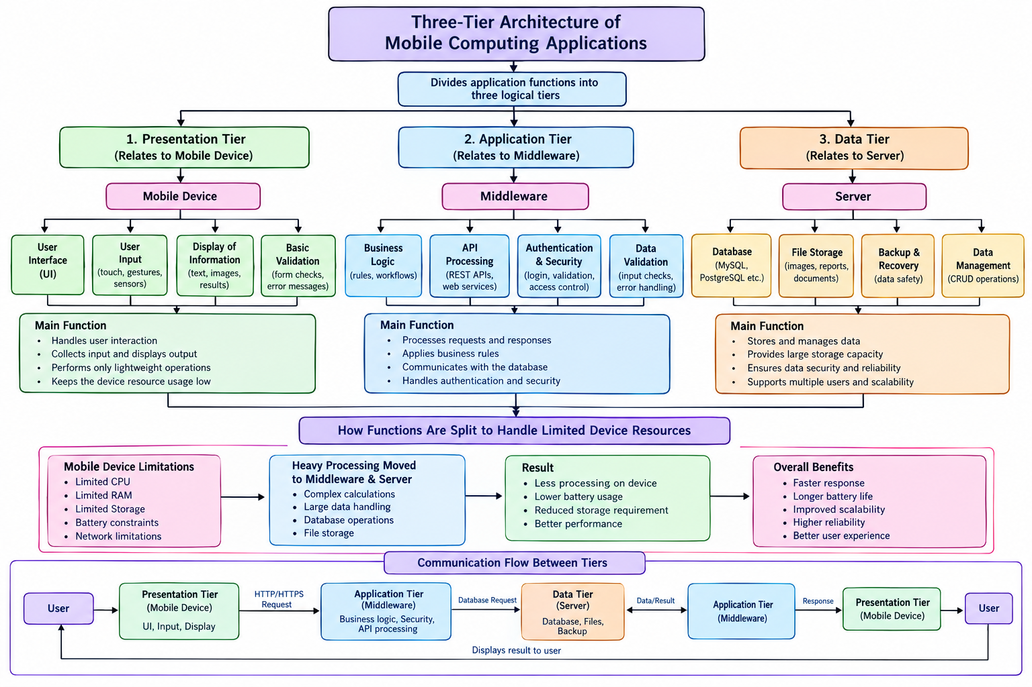

Three-Tier Architecture of Mobile Computing Applications
1. Introduction
- Three-tier architecture divides a mobile application into three layers: Presentation Tier, Application Tier and Data Tier.
- Each tier performs a specific function and communicates with the others.
- Purpose: To improve performance, security, scalability and resource utilization.
2. Presentation Tier — Mobile Device
- Provides the user interface on smartphones and tablets.
- User Interface: Displays screens, buttons and menus.
- User Input: Accepts touch, keyboard and sensor input.
- Display Information: Shows text, images and results.
- Basic Validation: Checks required fields and input formats.
- Main Function: Handles user interaction and lightweight operations.

3. Application Tier — Middleware
- Connects the mobile application with backend services.
- Business Logic: Applies application rules and workflows.
- API Processing: Receives requests and communicates with services.
- Authentication and Security: Verifies users and access permissions.
- Data Validation: Checks input before processing.
- Main Function: Processes requests, applies rules and coordinates communication with the Data Tier.
4. Data Tier — Server and Database
- Stores and manages application information.
- Database: Stores records using systems such as MySQL.
- File Storage: Stores images, documents and reports.
- Backup and Recovery: Helps restore lost or damaged data.
- Data Management: Performs Create, Read, Update and Delete (CRUD) operations.
- Main Function: Provides secure, reliable and persistent data storage.
5. Working of the Three Tiers
- The user enters information through the Presentation Tier.
- The Application Tier receives the request and validates it.
- The Data Tier retrieves or updates the required information.
- The Application Tier processes the result and sends a response.
- The Presentation Tier displays the result to the user.
Example: A doctor requests a patient report through a mobile app. The backend checks access permissions, retrieves the report from storage and displays it on the phone.
6. Handling Limited Mobile Device Resources
Mobile devices have limited CPU, RAM, storage and battery capacity.
- Limited CPU: Move suitable complex calculations to backend servers.
- Limited RAM: Process large datasets on backend resources when appropriate.
- Limited Storage: Store shared files and records on servers.
- Battery Constraints: Reduce unnecessary local processing and network requests.
- Network Limitations: Use efficient data transfer, caching and offline support where appropriate.
Result: Reduced device workload, potentially lower battery usage, improved responsiveness and efficient storage utilization.
7. Overall Benefits
- Better Performance: Distributes tasks across suitable resources.
- Scalability: Supports increasing users and workloads.
- Security: Enables centralized authentication and access control.
- Easy Maintenance: Allows individual tiers to be updated separately.
- Reliability: Supports data backup and recovery.
- Better User Experience: Provides organized and responsive application services.
8. Evaluation and Limitations
Advantages:
- Separates application responsibilities.
- Reduces unnecessary work on mobile devices.
- Supports centralized data management.
- Improves maintainability and scalability.
Limitations:
- Depends on network connectivity for backend operations.
- Server overload can reduce performance.
- Requires secure communication between tiers.
- Network requests may consume time and battery power.
9. Conclusion
- Three-tier architecture separates user interaction, application processing and data storage.
- The Presentation Tier manages the interface, the Application Tier processes requests, and the Data Tier manages information.
- Distributing functions helps manage limited mobile resources and supports better performance, security, scalability and maintainability.

